**Syngo Dynamics with QLAB Strain Usage Notes**

In Syngo Dynamics , open a study that has been acquired with an iE33 with native data and select an image;

Select the QLAB Button or from the Utilities menus choose Third Party Launchers and QLAB;

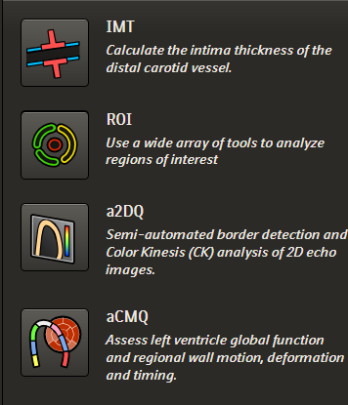QLAB will launch with the image in a new window;

Select a measurement module:  
 IMT, ROI, a2DQ or aCMQ;

**Perform the aCMQ (strain) in the order established withing Q Lab**

AP3, AP4, then AP2

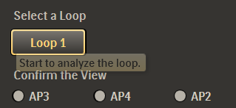

**Perform the desired available measurement operations.**

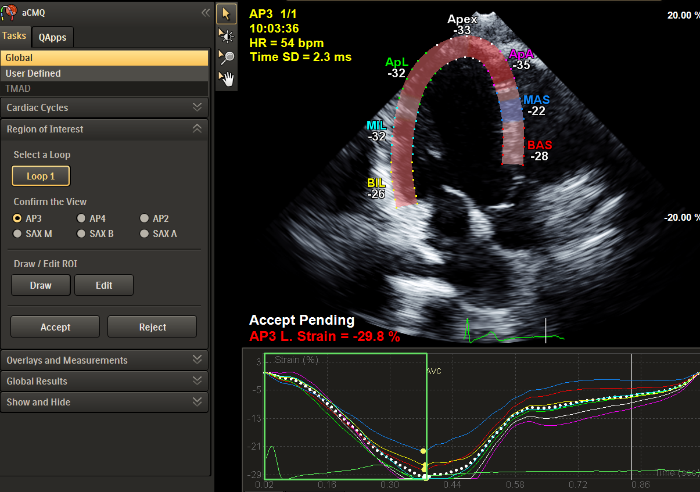

**Send Each Image or Cine to Syngo Dynamics**

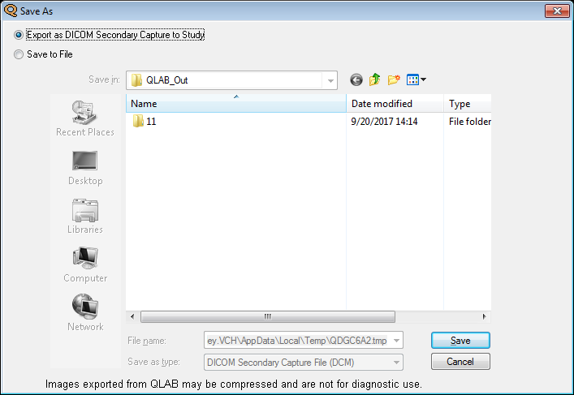Click on the “Film Send” button  at the bottom left corner;

Ensure the “Export as DICOM Secondary Capture to Study” radio button is selected;

Click on the Save button;

**To Send Measurements to Syngo Dynamics**

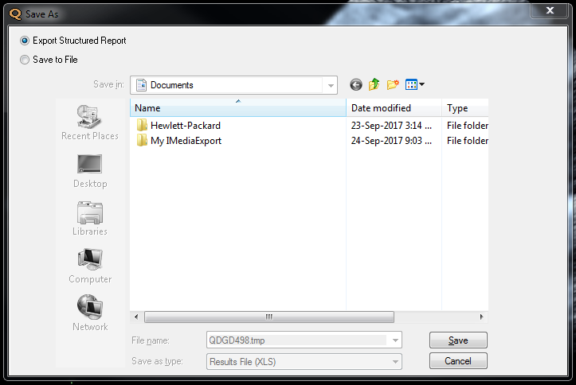

Click on the “Diskette” button 

Ensure the “Export Structured Report” radio button is selected;

Click on the Save button;

**Click Global Results** to obtain Bullseye and Global L Strain

Exit the module with the Exit button ;

Exit QLAB with the Exit button ;

The image will appear as the last series in the study in Syngo Dynamics.

Manually enter the QLab GLS into the QLab data button on the LV Measurements and Calcs page.

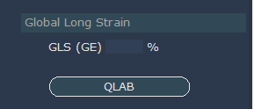

**Note: If changes are made to the patient demographics in Syngo Dynamics (to the database only) and then one runs QLAB, since the image files have the original demographics, the images an measurements won’t be sent to Syngo Dynamics.**