|  |  |  |
| --- | --- | --- |
|  | | |
| **Catheter** | **Strain relief** | **Luerlock connector** |

Lumbar CSF Drain – Medtronic Catheter

* **Strain relief prevents kinking at the connection between the catheter and luerlock connector**
* **Closed-tip catheter**
* **Distance to first marker = 11cm (needle length)**
* **5cm between markers**

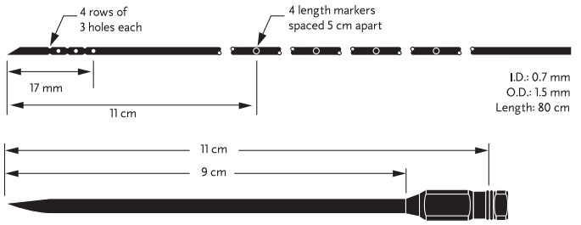

|  |  |
| --- | --- |
| If guidewire will be used, pre-flush catheter with saline before inserting guidewire   * Connect luerlock connector to catheter * Flush with saline |  |
| Threading guidewire into the catheter:   * Loosen the luer cap on the adjustable stop * Thread wire through adjustable stop out the rounded end and into the catheter (via the luer connector) to the catheter tip * Tighten the luer on the adjustable stop to affix the stop to the guidewire |  |
| **After catheter is insitu** | |
| 1. **Slide strain relief over catheter** |  |
| 1. **Connect luerlock connector w/ integral plug to catheter** |
| 1. **Slide strain relief up to snugly fit with the luerlock connector w/ integral plug** |
| 1. **Suture in the groove of the strain relief to secure it to the catheter (0-silk recommended)** |